Project Design Phase-II

Technology Stack (Architecture & Stack)

|  |  |
| --- | --- |
| Date | 22 October 2022 |
| Team ID | PNT2022TMID04545 |
| Project Name | Plasma Donor Application |
| Maximum Marks | 4 Marks |

Technical Architecture:

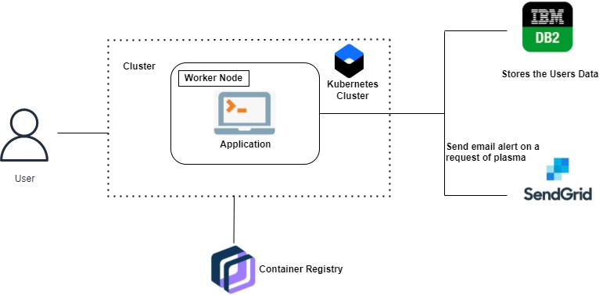

Table-1 : Components & Technologies:

|  |  |  |
| --- | --- | --- |
| **Component** | **Description** | **Technology** |
| User Interface | How user interacts with application e.g.  Web UI, Chatbot etc. | HTML, CSS, JavaScript / React Js |
| Application Logic-1 | New User registers in the application by giving the genuine contact details which will be stored in the database. | Java, Flask, HTML,CSS |
| Logic-2 | User login into the application by  providing the username and password. | Flask, IBM DB2 |
| Logic-3 | Stats page displays the blood unit count available and the number of donors available for each blood group  for which I need Plasma. | IBM Watson Assistant |
| Logic-4 | A request page that collects the name,contact number,gender and the blood group Plasma needed. | Sendgrid |
| Database | String,Integer,Characters,Long. | IBM DB2 |
| Cloud Database | IBM DB2 | IBM DB2. |
| External API-1 | Authentication | Flask. |
| External API-2 | Sending requests to donors. | Sendgrid |
| Infrastructure (Server / Cloud) | Application deployment | Kubernetes. |

**Table-2: Application Characteristics:**

|  |  |  |  |
| --- | --- | --- | --- |
| **S.N**  **o** | **Characteristics** | **Description** | **Technology** |
| 1. | Open-Source Framework | List the open-source framework used | Docker, Kubernetes |
| 2. | Security Implementation | List all the security / access controls implemented, use of firewalls etc. | Doctor Content Trust (DCT),Transport Layer Security (TLS**)** |
| 3. | Scalable Architecture | Justify the scalability of architecture (3 – tier, Micro-services) | Docker |
| 4. | Availability | use of load balancers | Kubernetes |
| 5. | Performance | Since Docker and Kubernetes are used the traffic load will be managed efficiently as a result of which the web application’s performance would  be much better. | Docker and Kubernetes |